**NAME: OBOH KINGSLEY OSEREMHEN**

**COURSE CODE: CPE522**

**MAT NO: ENG1403472**

**State Diagram of Door Combination Lock**

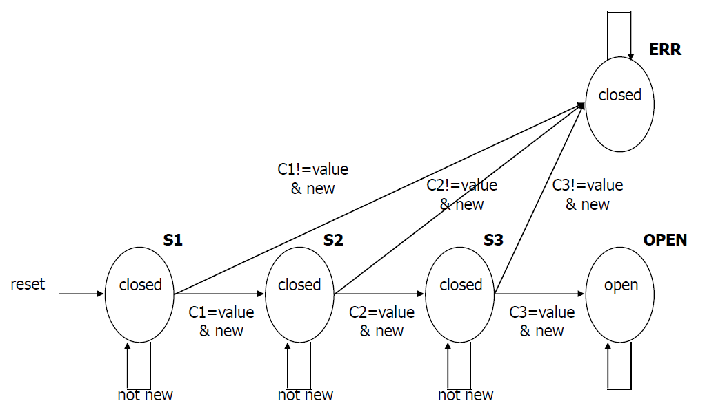

Fig 1.1 Door Combination Lock State Diagram

### **STATE TRANSITION TABLE**

|  |  |  |  |  |  |  |
| --- | --- | --- | --- | --- | --- | --- |
| Reset | New | Equal | Current State | Next  State | Next  Mux | Open / Closed |
| 1 | __ | __ | __ | S1 | C1 | closed |
| 0 | 0 | __ | S1 | S1 | C1 | closed |
| 0 | 1 | 0 | S1 | ERR | __ | closed |
| 0 | 1 | 1 | S1 | S2 | C2 | closed |
| 0 | 0 | __ | S2 | S2 | C2 | closed |
| 0 | 1 | 0 | S2 | ERR | __ | closed |
| 0 | 1 | 1 | S2 | S3 | C3 | closed |
| 0 | 0 | __ | S3 | S3 | C3 | closed |
| 0 | 1 | 0 | S3 | ERR | __ | closed |
| 0 | 1 | 1 | S3 | OPEN | __ | closed |
| 0 | __ | __ | OPEN | OPEN | __ | open |
| 0 | __ | __ | ERR | ERR | __ | closed |

### **ENCODING**

|  |  |
| --- | --- |
| SYMBOLS | ENCODING |
| S1 | 000 |
| S2 | 001 |
| S3 | 010 |
| OPEN | 011 |
| ERR | 100 |
|  |  |
| C1 | 00 |
| C2 | 01 |
| C3 | 10 |

### **STATE TRANSITION TABLE WITH ENCODED STATES**

|  |  |  |  |  |  |  |
| --- | --- | --- | --- | --- | --- | --- |
| Reset | New | Equal | Current State  s0, s1, s2 | Next  State  n0, n1, n2 | Next  Mux  c0, c1 | Open / Closed |
| 1 | __ | __ | __ | 000 | 00 | 0 |
| 0 | 0 | __ | 000 | 000 | 00 | 0 |
| 0 | 1 | 0 | 000 | 100 | __ | 0 |
| 0 | 1 | 1 | 000 | 001 | 01 | 0 |
| 0 | 0 | __ | 001 | 001 | 01 | 0 |
| 0 | 1 | 0 | 001 | 100 | __ | 0 |
| 0 | 1 | 1 | 001 | 010 | 10 | 0 |
| 0 | 0 | __ | 010 | 010 | 10 | 0 |
| 0 | 1 | 0 | 010 | 100 | __ | 0 |
| 0 | 1 | 1 | 010 | 011 | __ | 0 |
| 0 | __ | __ | 011 | 011 | __ | 1 |
| 0 | __ | __ | 100 | 100 | __ | 0 |

## **2.0 OUTPUTS**

The outputs are $n0, n1, n2, c0, c1 and Open$. The input variables are .

[AtozMath’s Online Quine McCluskey tool](http://atozmath.com/KMap.aspx?q=Quine) was used to find the minimal expression for each output as shown in the following sections.

### **2.1 For n0**

Minterm = 16,17,18,4,12,20,28

Don't Care = 5,6,7,13,14,15,21,22,23,29,30,31

Variable = r,n,e,s0,s1,s2

using Quine-McCluskey

[See solution here](http://atozmath.com/KMap.aspx?q=quine&q1=16%2c17%2c18%2c4%2c12%2c20%2c28%605%2c6%2c7%2c13%2c14%2c15%2c21%2c22%2c23%2c29%2c30%2c31%60r%2cn%2ce%2cs0%2cs1%2cs2%60sop&do=1#PrevPart)

Prime implicant chart

|  |  |  |  |  |  |  |  |  |
| --- | --- | --- | --- | --- | --- | --- | --- | --- |
| PIs\Minterms | 4 | 12 | 16 | 17 | 18 | 20 | 28 | r,n,e,s0,s1,s2 |
| 16,17,20,21 |  |  | X | X |  | X |  | 010-0- |
| 16,18,20,22 |  |  | X |  | X | X |  | 010--0 |
| 4,5,6,7,12,13,14,15,20,21,22,23,28,29,30,31 | X | X |  |  |  | X | X | 0--1-- |

Extracted essential prime implicants : 0--1--,010-0-,010--0

All extracted essential prime implicants : 0--1--,010-0-,010--0

Minimal QuineMcCluskey Expression = $r's0 + r'ne's1' + r'ne's2'$

### **2.2 For n1**

Minterm = 25,2,10,26,3,11,19,27

Don't Care = 5,6,7,13,14,15,21,22,23,29,30,31

Variable = r,n,e,s0,s1,s2

using Quine-McCluskey

[See solution here](http://atozmath.com/KMap.aspx?q=quine&q1=25%2C2%2C10%2C26%2C3%2C11%2C19%2C27%605%2C6%2C7%2C13%2C14%2C15%2C21%2C22%2C23%2C29%2C30%2C31%60r%2Cn%2Ce%2Cs0%2Cs1%2Cs2%60sop&do=1)

Prime implicant chart

|  |  |  |  |  |  |  |  |  |  |
| --- | --- | --- | --- | --- | --- | --- | --- | --- | --- |
| PIs\Minterms | 2 | 3 | 10 | 11 | 19 | 25 | 26 | 27 | r,n,e,s0,s1,s2 |
| 25,27,29,31 |  |  |  |  |  | X |  | X | 011--1 |
| 2,3,6,7,10,11,14,15 | X | X | X | X |  |  |  |  | 00--1- |
| 3,7,11,15,19,23,27,31 |  | X |  | X | X |  |  | X | 0---11 |
| 10,11,14,15,26,27,30,31 |  |  | X | X |  |  | X | X | 0-1-1- |
| 5,7,13,15,21,23,29,31 |  |  |  |  |  |  |  |  | 0--1-1 |
| 6,7,14,15,22,23,30,31 |  |  |  |  |  |  |  |  | 0--11- |

Extracted essential prime implicants : 00--1-,0---11,011--1,0-1-1-

All extracted essential prime implicants : 00--1-,0---11,011--1,0-1-1-

Minimal QuineMcCluskey Expression = $r'n's1 + r's1s2 + r'nes2 + r'es1$

### **2.3 For n2**

Minterm = 24,1,9,26,3,11,19,27

Don't Care = 5,6,7,13,14,15,21,22,23,29,30,31

Variable = r,n,e,s0,s1,s2

using Quine-McCluskey

[See solution here](http://atozmath.com/KMap.aspx?q=quine&q1=24%2c1%2c9%2c26%2c3%2c11%2c19%2c27%605%2c6%2c7%2c13%2c14%2c15%2c21%2c22%2c23%2c29%2c30%2c31%60r%2cn%2ce%2cs0%2cs1%2cs2%60sop&do=1#PrevPart)

Prime implicant chart

|  |  |  |  |  |  |  |  |  |  |
| --- | --- | --- | --- | --- | --- | --- | --- | --- | --- |
| PIs\Minterms | 1 | 3 | 9 | 11 | 19 | 24 | 26 | 27 | r,n,e,s0,s1,s2 |
| 24,26 |  |  |  |  |  | X | X |  | 0110-0 |
| 26,27,30,31 |  |  |  |  |  |  | X | X | 011-1- |
| 1,3,5,7,9,11,13,15 | X | X | X | X |  |  |  |  | 00---1 |
| 3,7,11,15,19,23,27,31 |  | X |  | X | X |  |  | X | 0---11 |
| 5,7,13,15,21,23,29,31 |  |  |  |  |  |  |  |  | 0--1-1 |
| 6,7,14,15,22,23,30,31 |  |  |  |  |  |  |  |  | 0--11- |

Extracted essential prime implicants : 00---1,0---11,0110-0

All extracted essential prime implicants : 00---1,0---11,0110-0

Minimal QuineMcCluskey Expression = $r'n's2 + r's1s2 + r'nes0's2'$

### **2.4 For c0**

Minterm = 25,2,10

DontCare = 16,17,18,26,4,12,20,28,3,11,19,27,5,6,7,13,14,15,21,22,23,29,30,31

Variable = r,n,e,s0,s1,s2

using Quine-McCluskey

[See solution here](http://atozmath.com/KMap.aspx?q=quine&q1=25%2c2%2c10%6016%2c17%2c18%2c26%2c4%2c12%2c20%2c28%2c3%2c11%2c19%2c27%2c5%2c6%2c7%2c13%2c14%2c15%2c21%2c22%2c23%2c29%2c30%2c31%60r%2cn%2ce%2cs0%2cs1%2cs2%60sop&do=1)

Prime implicant chart

|  |  |  |  |  |
| --- | --- | --- | --- | --- |
| PIs\Minterms | 2 | 10 | 25 | r,n,e,s0,s1,s2 |
| 16,17,18,19,20,21,22,23 |  |  |  | 010--- |
| 17,19,21,23,25,27,29,31 |  |  | X | 01---1 |
| 2,3,6,7,10,11,14,15,18,19,22,23,26,27,30,31 | X | X |  | 0---1- |
| 4,5,6,7,12,13,14,15,20,21,22,23,28,29,30,31 |  |  |  | 0--1-- |

Extracted essential prime implicants : 0---1-,01---1

All extracted essential prime implicants : 0---1-,01---1

Minimal QuineMcCluskey Expression = $r's1 + r'ns2$

### 

### **2.5 For c1**

Minterm = 24,1,9

DontCare = 16,17,18,26,4,12,20,28,3,11,19,27,5,6,7,13,14,15,21,22,23,29,30,31

Variable = r,n,e,s0,s1,s2

using Quine-McCluskey

[See solution here](http://atozmath.com/KMap.aspx?q=quine&q1=24%2c1%2c9%6016%2c17%2c18%2c26%2c4%2c12%2c20%2c28%2c3%2c11%2c19%2c27%2c5%2c6%2c7%2c13%2c14%2c15%2c21%2c22%2c23%2c29%2c30%2c31%60r%2cn%2ce%2cs0%2cs1%2cs2%60sop&do=1#PrevPart)

Prime implicant chart

|  |  |  |  |  |
| --- | --- | --- | --- | --- |
| PIs\Minterms | 1 | 9 | 24 | r,n,e,s0,s1,s2 |
| 1,3,5,7,9,11,13,15 | X | X |  | 00---1 |
| 1,3,5,7,17,19,21,23 | X |  |  | 0-0--1 |
| 16,18,20,22,24,26,28,30 |  |  | X | 01---0 |
| 16,17,18,19,20,21,22,23 |  |  |  | 010--- |
| 3,7,11,15,19,23,27,31 |  |  |  | 0---11 |
| 18,19,22,23,26,27,30,31 |  |  |  | 01--1- |
| 4,5,6,7,12,13,14,15,20,21,22,23,28,29,30,31 |  |  |  | 0--1-- |

Extracted essential prime implicants : 00---1,01---0

All extracted essential prime implicants : 00---1,01---0

Minimal QuineMcCluskey Expression = $r'n's2 + r'ns2'$

### **2.6 For Open**

Minterm = 3,11,19,27

DontCare = 5,6,7,13,14,15,21,22,23,29,30,31

Variable = r,n,e,s0,s1,s2

using Quine-McCluskey

[See solution here](http://atozmath.com/KMap.aspx?q=quine&q1=3%2C11%2C19%2C27%605%2C6%2C7%2C13%2C14%2C15%2C21%2C22%2C23%2C29%2C30%2C31%60r%2Cn%2Ce%2Cs0%2Cs1%2Cs2%60sop&do=1#tblSolution)

Prime implicant chart

|  |  |  |  |  |  |
| --- | --- | --- | --- | --- | --- |
| PIs\Minterms | 3 | 11 | 19 | 27 | r,n,e,s0,s1,s2 |
| 3,7,11,15,19,23,27,31 | X | X | X | X | 0---11 |
| 5,7,13,15,21,23,29,31 |  |  |  |  | 0--1-1 |
| 6,7,14,15,22,23,30,31 |  |  |  |  | 0--11- |

Extracted essential prime implicants : 0---11

All extracted essential prime implicants : 0---11

Minimal QuineMcCluskey Expression = $r's1s2$